**Product Development Competition: Initial Submission**

**1. Project Overview**

* **Project Title:** Smart Business Dashboard For Small And Medium Scale Business
* **Team Name:** Brightreds
* **Institution:** Kongu Engineering College
* **Team Members:**
  + Akkshay K R- Web Developement
  + Pranav A S- Web Development
  + Pranav Raja M- Web Developement
  + Aishwariya SK- Model Creation and Analytics
  + Aiswarya M - Model Creation and Analytics
* **Date:** 11.09.2024

**2. Problem Statement**

* **Business Challenge:** Many small and medium-sized businesses (SMBs) struggle to make data-driven decisions because they lack access to real-time, actionable insights across key areas like sales, customer behaviour, and inventory management. This lack of visibility often leads to poor resource allocation, missed sales opportunities, and inefficiencies in operations.
* **Target Audience:** The primary users of this product are SMB owners, even those who do not have much technical expertise looking to gain better control and visibility over their business operations. Specifically, the dashboard is aimed at retail, and service-based businesses that need streamlined access to performance data.

**3. Background**

* **Context:** SMBs operate with limited resources and lack the sophisticated tools that larger enterprises use to make informed decisions. In an increasingly competitive business landscape, SMBs are actively seeking business intelligence solutions to enhance decision-making, improve operational efficiency, and maintain a competitive edge in the market.
* **Existing Solutions:** Current business intelligence tools available for SMBs are often either too simplistic or overly complex, requiring expensive customizations. Many SMBs rely on spreadsheets or basic analytics from individual platforms that provide a fragmented view of their business.
* **Why This Product:** It leverages machine learning to generate predictive insights, providing SMBs with the same level of intelligence that larger enterprises have, but at a fraction of the cost and complexity. It also provides multi-lingual support.

**4. Product Concept**

* **Vision:** To empower SMBs by providing an all-in-one business intelligence dashboard that delivers real-time insights into sales, customer behaviour, and operational metrics, helping businesses make informed, data-driven decisions.
* **Key Features:**
  + Sales and Revenue Tracking
  + Customer Insights
  + Inventory Management
  + Automated Reporting
  + Predictive Analysis
  + Interactive Visualizations
* **Unique Value:** It is an easy-to-use predictive analytics tool powered by machine learning specifically tailored for SMBs. It creates multiple useful visualisations along with generation of report with key insights in multiple languages.

**5. Business Value**

* **Benefits:**
  + Increased operational efficiency through automated reporting and inventory management.
  + Improved decision-making via real-time insights into sales and customer behaviour.
  + Better resource allocation and forecasting through predictive analysis.
* **Market Potential:** With the global SMB market growing rapidly and awareness about the impact of data analysis, there is significant demand for cost-effective business intelligence tools.
* **Revenue Model:** Subscription-based pricing model with tiered levels based on the number of features and integrations required. Higher tier pricing includes full access to all features, including custom database creation, customized visualizations tailored to specific client requirements. Lower tier pricing includes access to standard visualizations with basic performance metrics and reporting tools.

1. **Cost Overview**

* **Development Costs**: The total development cost includes ₹8,000 for software and manpower costs for 5 members working 100 days, each earning ₹300 per day. The total manpower cost is ₹150,000. Converting this to USD (at ₹83 per USD), the total development cost is approximately **$1,807**, covering technology, manpower, and testing.
* **Operational Costs**: Ongoing operational costs could include additional expenses such as server hosting, maintenance, and support. This could be an estimated monthly cost of **$100-$150**, depending on infrastructure and scaling needs.
* **Cost-Benefit Analysis**: The initial development cost of approximately **$1,807** is minimal compared to the potential business value, which includes scalability and serving multiple clients. The low manpower and software costs allow for quick return on investment as the product can be rolled out efficiently.

1. **User Interface (UI)**

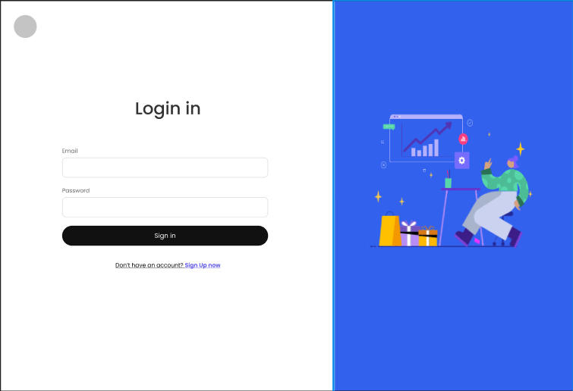

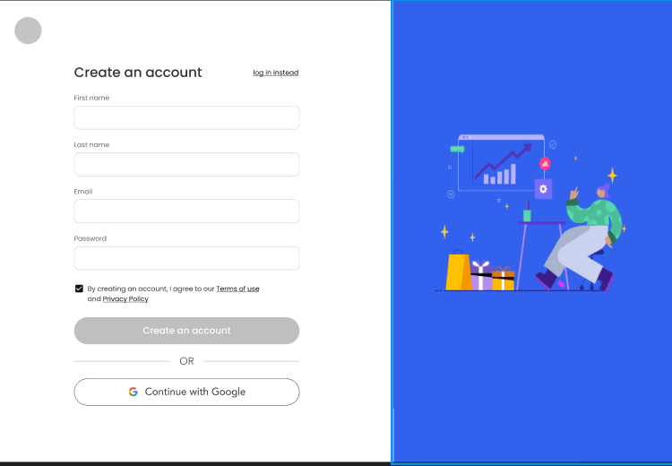

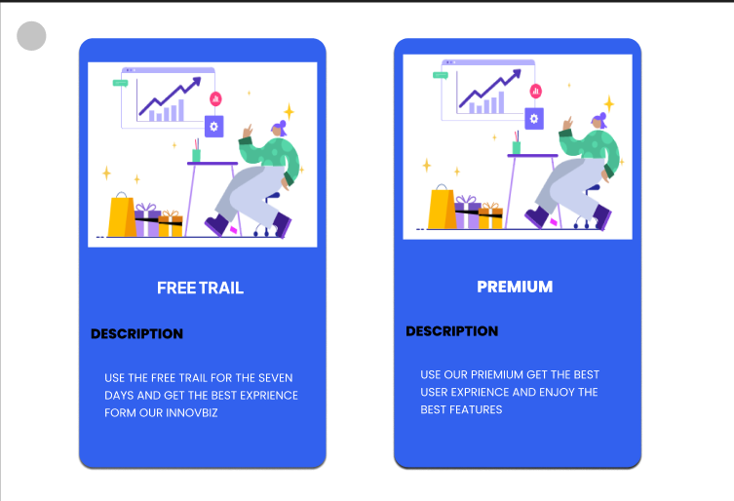

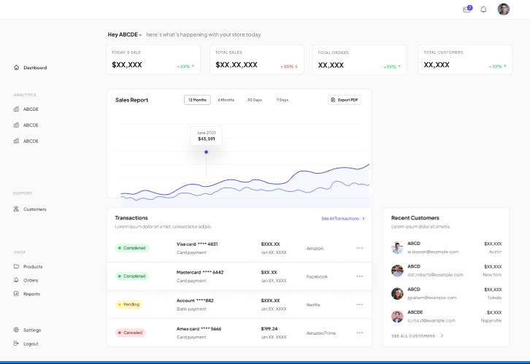

**8. Technical Overview**

* **Components:**
  + Data Integration Module: Collects and processes data from connected platforms
  + Visualization Module: Generates dynamic charts, graphs, and dashboards for easy data interpretation.
  + Reporting Module: Automates the creation of custom reports.
  + AI & Predictive Analysis Module: Uses machine learning algorithms to generate insights and forecasts.
* **Technologies:**
  + Backend: Python for data processing and AI models.
  + Frontend: React.js for building the dashboard interface.
  + Database: mySQL for data storage.
  + Cloud Hosting: AWS for scalable and reliable infrastructure.
* **Integration:** The data integration module will use APIs to pull data from third-party platforms. The AI engine will process this data in real-time and provide predictive insights, which will be displayed through the visualization module.

**9. Conclusion**

* **Summary:** The Smart Business Dashboard offers SMBs an all-in-one solution for tracking business performance, analysing customer behaviour, and managing inventory. It leverages machine learning to offer predictive insights, helping businesses make data-driven decisions that improve efficiency and profitability.
* **Next Steps:**
  + Finalize UI/UX design based on feedback from potential users.
  + Begin development of the core dashboard features, followed by testing with select SMBs.
  + Plan for beta launch and user feedback collection before scaling to a wider audience.